Dry Hydrants
- 79 Adams Lane Pond
- 145 Braeburn Drive Pond
- 573 Cascade Road Pond
- 571 Cheese Spring Road Pond
- Comstock Hill Road Pond @ Silvermine Art Guild
- 95 Country Club Road Pool @New Canaan Country Club
- 95 Country Club Road Pond @New Canaan Country Club
- 23 Father Peter’s Lane Pool
- 91 Four Winds Lane Pool
- 205 Hickock Road Pond
- 381 Hoyt Farm Road Pond
- 204 Indian Waters Drive Pool
- 64-75 Lake Wind Road Pond
- 181 Lambert Road Pond
- 37 Long Lots Road Pond
- 76 Louise’s Lane Pool
- 365 Lukes Wood Road Cistern @ Grace Farms
- 266 Michigan Road Pond
- 10 Millport Avenue Pond
- 377 North Wilton Road Cistern @ St. Lukes School
- 377 North Wilton Road Pond @ St. Lukes School
- 721 North Wilton Road Cistern
- 544 Oenoke Ridge Road Pool
- 789 Oenoke Ridge Road Pool
- Pequot Lane Cistern
- 208 Ponus Ridge Road Pond
- 1371 Ponus Ridge Road Pool
- 1544 Ponus Ridge Road Pond
- Ponus Ridge Road@Greenley Rd. Pond
- 119 Proprietors Crossing Cistern
- Puddin Hill Road Pond
- 56 Rosebrook Road Pool
- 1035 Silvermine Road Pond @Silvermine Art Guild
- 687 Smith Ridge Road Cistern
- 1218 Smith Ridge Road Pond
- 59 Summersweet Road Pool
- 61 Summersweet Road Pool
- 76 Turtleback Lane West Pool
- 84 Turtleback Road Pool
- Wellesley Drive @ Woodridge Circle Cistern
- 707 West Road Pool
- West Road @ Lost District Drive Pond
- West Road Bridge Rippowam River
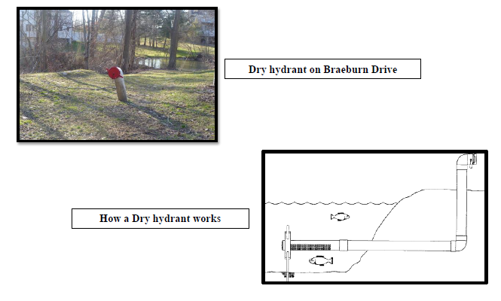
- 64 Wydendown Road Cistern

